SPRINGHILL CATHOLIC PRIMARY SCHOOL

We strive to achieve excellence in all that we do as we follow the Gospel values of Jesus Christ.

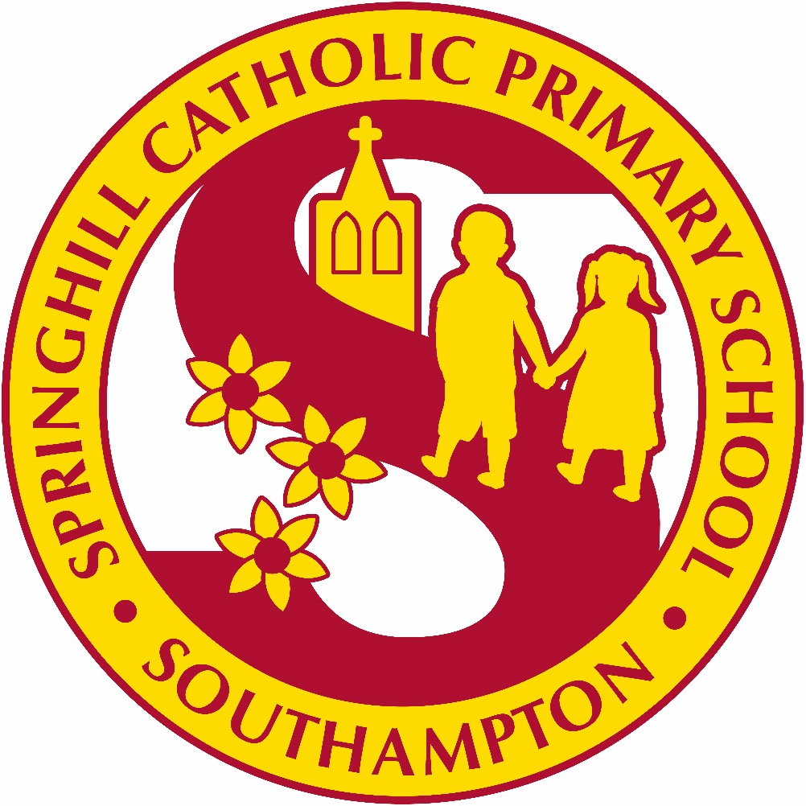

Together we will do our best for Jesus

Uniform Policy

This school is committed to safeguarding and promoting the welfare of children and young people and expects all staff and volunteers to share this commitment

Date: 8th June 2026
Review Date: July 2027

Springhill Catholic Primary School Uniform Policy
The school uniform is compulsory and is supported by all parents. Please ensure all items of school uniform are labelled. On page 3 of this document are visuals of the school uniform.

Winter Uniform:
The school winter uniform is worn from September through to the Easter Holidays.

Essential: Grey skirt, pinafore, trousers or shorts, white shirt and school tie.

Burgundy jumper or cardigan with the school logo.

Grey or burgundy tights and grey school socks are allowed. Only in year 5 and 6 – girls may wear black tights (40 denier or above)
Black closed school shoes (no trainers, sandals or boots allowed).
School book bag in Year F-2.
Optional: burgundy parka or fleece with the school logo.

A coat is required for school. No denim jackets or colourful fleeces are allowed.

In Year 6, parents are given the opportunity to purchase a leavers hoodie. These may be worn at break and lunch times by the children but not in class. They will still require a school jumper to keep them warm.

Summer Uniform:
The summer uniform can be worn from after the Easter holidays through to July when the summer holidays begin.

Shirt and tie may be replaced with a white polo shirt (this can be a plain white polo or the polo with the
school logo). Girls may wear a yellow and white checked dress.
Black closed school shoes (no trainers, sandals or boots allowed).
School book bag in Year F-2.

PE kit:
PE kit is needed all year round, on PE days, children will change into their kit at school. They then will finish the school day in their kit and go home in it so it can be washed and returned ready for every Monday.
Essential PE kit
Black shorts, gold t-shirt and black plimsolls.
Black tracksuit trousers may be worn in the winter for outdoor games
No branded items allowed.
Black plimsoll shoes are needed for children In Year F, 1 and 2.
Black trainers are needed for children in Year 3-6.

Bags:
PE kit bags and book bags with the school logo.
As locker space is limited, FS, Year 1 and Year 2 are not to bring in backpack. They are only to use a bookbag. Year 3 – 6 may bring in a backpack.

Jewellery:
Should not be worn to school. If a child has pierced ears, then we permit the wearing of one pair of small, plain studs, even these can be dangerous in a playground situation and must be removed or taped over for PE lessons.

Hats:
Suitable protective head gear for sunny weather or cold weather

Hair:
Plain, narrow hair band, ribbon or scrunchie in the school colours. Designs shaved in hair or dyed hair are not suitable for school.
Long hair must be tied up.

Any family experiencing difficulty in purchasing the school uniform should speak to the Head Teacher or the Home Link Worker.

Please make sure all uniform is named.

Uniform can be ordered online from the following websites or in store:
Koolskools:
https://www.koolskools.co.uk/product-category/springhill-catholic-primary-school/
Uniform can also be ordered and collected from the Koolskools shop at:
387 Shirley Road, SO15 3TS

Tel: 023 8077 1839

Skoolkit:
https://skoolkit.co.uk/school-uniform/1450
Uniform can also be tried on at:
1 Commercial Road, Totton, SO40 3BX and 31 Leigh Road, Eastleigh, SO50 9FF
Tel: 02380667600

Special Educational Needs:
As our uniform is easy to wear, adaptations aren’t generally required. In the rare event that an adaptation is required, this would need to be agreed by the SENDCo.


