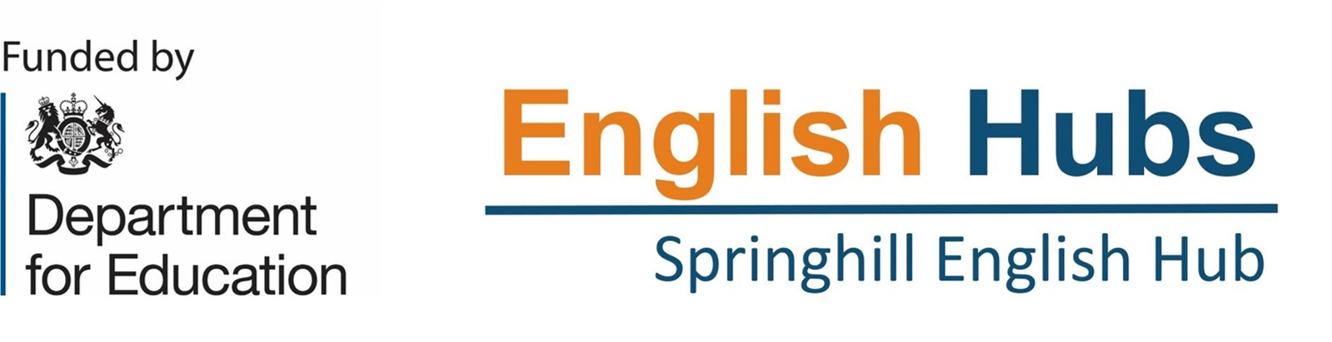

We have two vacancies for administration positions within our English Hub based at Springhill Catholic Primary School.

English Hub Administration Assistant –
35 hours a week – Term time Only – 39 weeks per year
Monday to Friday 8.30am – 4.00pm (hours could be negotiated if required)
Actual - £20,112 - £24,389 / FTE - £24,790 - £30,060

English Hub Finance Administration –
30 hours per week – Term time only, plus one week in August – 40 weeks per year
Monday to Friday 8.30am – 3.00pm (hours could be negotiated if required)
Actual - £18,886 - £21,373.22 / FTE £26,562 - £30.060

These positions would start on 1st September 2026
A job description, person specification and a Catholic Education Service support staff application form is available from the school office or on the website http://www.springhillcatholic.co.uk/staff-vacancies/
Applications will only be accepted on the Catholic Education application forms.
Closing date for applications: Tuesday 14th July 2026 – 9.00am
We will be considering applications as received and may close the position earlier if a suitable candidate is found.

This school is committed to safeguarding and promoting the welfare of children and young people and expects all staff and volunteers to share this commitment. This post is subject to an Enhanced Disclosure check with the Disclosure and Barring Service.

