SPRINGHILL CATHOLIC PRIMARY SCHOOL

We strive to achieve excellence in all that we do as we follow the Gospel values of Jesus Christ.

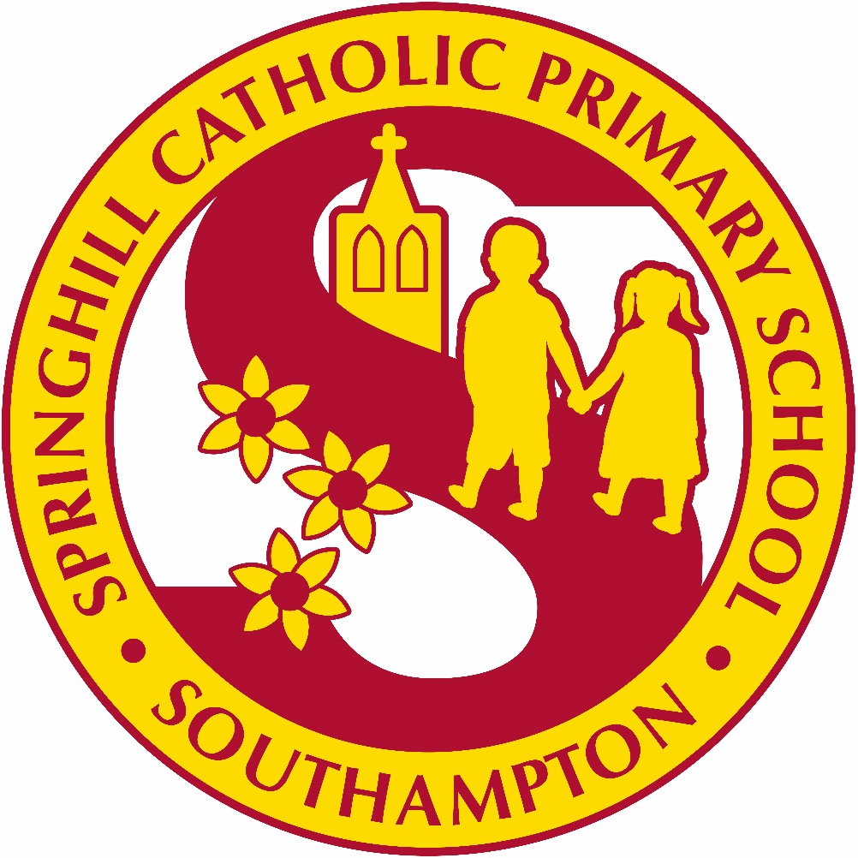

Together we will do our best for Jesus

Celebration of the word

This school is committed to safeguarding and promoting the welfare of children and young people and expects all staff and volunteers to share this commitment

Adopted by the Governing Body: 18th May 2026
Review Date: May 2028
Introduction:
Understanding Prayer and Liturgy:
In any school there will be a range of prayer and liturgy: classroom prayer, meditation,
assemblies, devotions, special services for times in the school year, celebrations of Mass and
the Sacrament of Reconciliation. Each form of prayer and liturgy will have its own character
dependent on the circumstances, size and age of the group, the place of celebration and its
content.
Definition of Terms:
Prayer, Liturgical Prayer, and Liturgy form a continuum with silent meditation at one end
and a celebration of Mass on a Solemnity of the Church (e.g., Ascension of the Lord) at the
other. Of course, there are areas of overlap between the categories.
Types:
Prayer: Christian meditation, Prayer before meals, Devotions
Liturgical Prayer: Service of the Word, Assembly, Liturgy of Hours, Benediction
Liturgy: Sacraments, Mass, Penance
Layout:
Prayer: Simple structure, One or two elements, Balance of familiarity & creativity
Liturgical Prayer: Structured (often 4 part), Elements drawn from liturgy, Places of Scripture, Contrasts and creativity
Liturgy: Taken from official books, Complex structure, Many elements, Range of ministry

In Catholic terminology ‘worship’ is not generally used to name and describe a distinct type
of prayer or event. Worship is about living our lives in a way that recognises that everything
we have is a gift from God and that everything we do gives glory to God. That, of course,
does include prayer but the scope is broader. With that understanding of worship it will be
seen that that the purpose of education in a Catholic school is to know and love Christ and to open the vision and imagination of all pupils to the wonder of living in God’s world, and the responsibilities that follow from this.

Mission Statement:
“Together, we will do our best for Jesus.”

The Nature of Prayer and Liturgy:
Prayer and liturgy in a Catholic school names and celebrates God’s presence in our lives. It is concerned with giving glory, honour, praise and thanks to God. It is our loving response, in word and action, to God’s invitation to enter into relationship, made possible through the work of Jesus Christ and the witness of the Holy Spirit.
‘The celebration of Catholic liturgies and prayers as an integral part of the learning and teaching should enable the school community to become reflective, experience the presence of God and should develop a mature spiritual life.’ (Rev Marcus Stock)

Legal Requirements:
It is a legal requirement that there is a daily ‘act of worship’ offered for all pupils. This can take place at any time during the school day and can be either a single ‘act of worship’ for all pupils, or separate ‘acts of worship’ in school groups. Holding an assembly that includes a prayer, said either by the teacher or everyone present, does not fulfil this requirement. Prayer, liturgical prayer and assembly are distinct activities. They may sometimes form part of the same gathering, but the difference between will always be made clear.
The ‘act of worship’ is not designated curriculum time under regulations and will not be subsumed under any part of the curriculum, including religious education. Responsibility for arranging prayer and liturgy lies with the Governing Body after consultation with the headteacher.
Parents have a right to withdraw their child from ‘Collective Worship’. However, given the
importance of prayer and liturgy in a Catholic school, parents and prospective parents will be made aware of the fact that it can never be confined to ‘timetabled slots’ but may take place in a variety of contexts other that those which are specifically structured, within the RE curriculum.

The Place of Prayer and Liturgy in the Life of Springhill Catholic Primary School:
Prayer and liturgy is an integral part of school life and central to the Catholic tradition.
Prayer and liturgy takes into account the religious and educational needs of all who share in it:
● Those who form part of the worshipping community in church;
● Those for whom school may be their first and only experience of church;
● Those from other Christian traditions – or none;
● Those from other faith backgrounds.

The Aims of Prayer and Liturgy:
Prayer and liturgy in Springhill Catholic Primary School aims to provide opportunities for all pupils and staff:
● To contemplate the mystery of God
● To reflect on spiritual and moral issues
● To explore personal beliefs
● To respond to and to celebrate life
● To experience a sense of belonging and to develop community spirit
● To develop a common ethos and shared values
● To enrich religious experience
● To grow in liturgical understanding and development
● To pray using prayers which are part of the Catholic tradition
● To reinforce positive attitudes
● To participate fully
● To take time out ‘to wonder at’, ‘to come to terms with’ and ‘to give worth to.’

Principles:
All acts of prayer in Springhill Catholic Primary School will:
● Give glory and honour to God;
● Be a quality activity, fundamental to the life of the school and its Catholic character;
● Enable pupils to develop skills so that they can prepare, organise and lead prayer times;
● Give pupils positive liturgical experiences, appropriate to their age, aptitude and family
backgrounds in order to prepare them for the liturgical life of the Church. Celebrations will be appropriate to the age and groupings of the children.

Planning, content and celebration:
Prayer and liturgy is planned following a structure with reference to the Church's seasons, feast days, the curriculum and significant dates e.g. CAFOD Family Fast Day, Holocaust Memorial Day.
Parish and parents are invited to participate in some celebrations.
A variety of prayer styles will be used appropriate to the age of the children and the occasion.

Monday: | Tuesday: | Wednesday: | Thursday: | Friday: | Every day:
Key Stage Gospel Prayers | Class CW | Class CW  Staff prayer | Class CW | Year Group Prayers | Morning Prayer  Lunch Prayer  End of Day Prayer  Spontaneous Prayer
In Year 5 and 6 – the children lead 1-2 CW class sessions a week
Year Prayer Chaplains lead prayer for the KS1 classes once a week.

Leading Prayer and Liturgy:
As faith leader of the school, the Headteacher will plan and lead prayer and liturgy. The Deputy Head Teacher and Senior Leaders also lead whole school prayer times. The class teacher will lead class prayer and liturgy depending on the year group. Children are taught to plan and lead prayer times according to their age.

Recording:
Prayer and liturgy is recorded in a liturgy planner. In EYFS, Year 1 and Year 2, the class teacher will fill out the prayer and liturgy plan for their class. In Key Stage Two, children will fill these out.

Monitoring and Evaluation:
Prayer and liturgy is monitored using prayer and liturgy monitoring form. See Appendix 2. Monitoring is completed on a termly basis. Following monitoring, training needs will be identified and outcomes used to inform the school’s CSED (Catholic Schools Evaluation Document).

Resources:
Children use “Pray 2gether” to support them in planning and delivering their liturgies. They also have access to websites such as CAFOD and Mission Together to further enhance their experience. The class teacher is responsible for managing resources in each classroom. A yearly audit is completed to ensure that children have the best resources to access. All resources are kept in classrooms and are accessible to all children. Children also have the responsibility to ensure that resources are managed and looked after.

The learning environment:
'Symbols and icons of the Catholic faith when displayed in school and throughout its premises will help the school community and visitors to experience the uniqueness and sacredness of this learning environment. Focal points in each classroom and throughout the school will reflect the liturgical season and will reference RE topics. In this way they will be an outward sign of the school's ethos.

Retreats:
Year 6 – The Common
Staff - ?

Other opportunities:
There are monthly masses in our parish Church and mass frequently takes place in school. Parents, grandparents, parishioners and governors are invited where possible. Please see below:
Across the year, pupils will have:
Start of year mass
All Saints mass
Advent mass
Reconciliation Services
Adoration
Epiphany mass
Palm burning
Ash Wednesday service
Holy Week tableaus
Easter Mass
Pentecost Mass
Ascension Mass
First Communion Celebration Mass
Crowning of Mary
Feast Day celebrations of house saints
Leavers’ Mass

Eucharist:
Children attend the Sacrament of Reconciliation and receive the Sacrament of the Eucharist yearly. Children are also involved in The Children of the Eucharist. The Children of the Eucharist offers spiritual and evangelistic programs to guide the children and youth of the world in responding to and living out the words of Jesus. The Children of the Eucharist is led by school staff and is a priority within school.

The Coordinator for Prayer and Liturgy:
The RE team is the Coordinator for Prayer and Liturgy.

Policy Monitoring and Review:
This policy is monitored by the Prayer and Liturgy Coordinator and is evaluated and reviewed by the whole school staff and governors every two years. The Foundation Governors in particular will play a most important role.

