
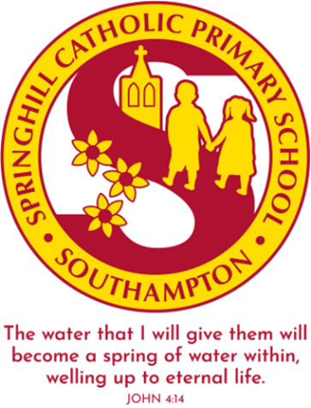
Springhill Catholic Primary School
Year 2 Curriculum Update
Summer 2 2026
Dear parents and carers,
The children have now reached their final half term in Year 2! It has been a wonderful year so far, but we still have so many exciting activities before the end of the Summer term.
This half term in PE, the children will start to practise Sports Day events so they are able to select the activities they would prefer to take part in.
In science, the children will be finishing the topic of Animals, including Humans. Then, we will move onto the Plants topic, which will include growing sunflowers from seeds and identifying which conditions are necessary for a seed to grow.
In DT, the children will complete and evaluate their pencil cases. This half term, the children will learn how to make and bake a delicious fruit crumble.
In geography, the children will continue to compare our city, Southampton, with Chembakolli in India. In classes, they will complete fieldwork at Bedford place.
Key dates:
Friday 5th June 5-6pm – Year 2 Pyjama Story Time
Saturday 13th June – PA Summer Festival
Tuesday 16th June – 2JH Geography Fieldwork at Bedford Place
Wednesday 17th June – 2EW Geography Fieldwork at Bedford Place
Thursday 18th June – 2LW Geography Fieldwork at Bedford Place
Friday 19th June – St Peter and St Paul Liturgy
Friday 19th June – Diversity Day
Tuesday 30th June 1:20pm –Year 1 and 2 Sports Day
Friday 3rd July – Year 2 Titanic Dress Up Day
Monday 13th July 3:30pm – KS1 Choir Concert
Wednesday 15th July – St Maximilian Feast Day
Thursday 16th July – School books sent home
Mon 20th, Tues 21st and Wed 22nd July – INSET days
Thursday 23rd July – School Summer holidays begin
The children have worked so hard this year, and they have developed their learning mindset. It has been a pleasure to see how they have matured during their time in Year 2.
In RE, the children will be thinking about the promise Jesus kept at Pentecost to complete the topic of Pentecost and Mission. Then, the final RE topic in Year 2 will be Sacraments, with a focus on the sacraments of baptism and marriage.
In reading, the children will read independent texts and their Reading Anthology to develop their skills when answering retrieval questions and make predictions based on what they have read. The children will practice reading with expression and finding out the meaning of unfamiliar words.
In writing, the children will be using the skills they have been taught this year, including character and setting descriptions, story recounts, non-chronological reports and diary entries. The children will continue to practise their editing skills to improve their content and the accuracy of punctuation in their writing.
In maths, the children will learn about statistics, using a tally and interpreting tables, and position and direction. We will also be revisiting the Year 2 maths content to recap and embed their prior learning.
In class, the children will continue to practise telling the time past the hour and to the hour in five-minute intervals. Please continue to practise at home too so they can demonstrate their time telling skills to earn their own analogue watch to wear to school.
Please remember to read daily with your child and complete the reading challenge. Daily reading will ensure your child has the best start in life.

