Literacy Specialists (LS)
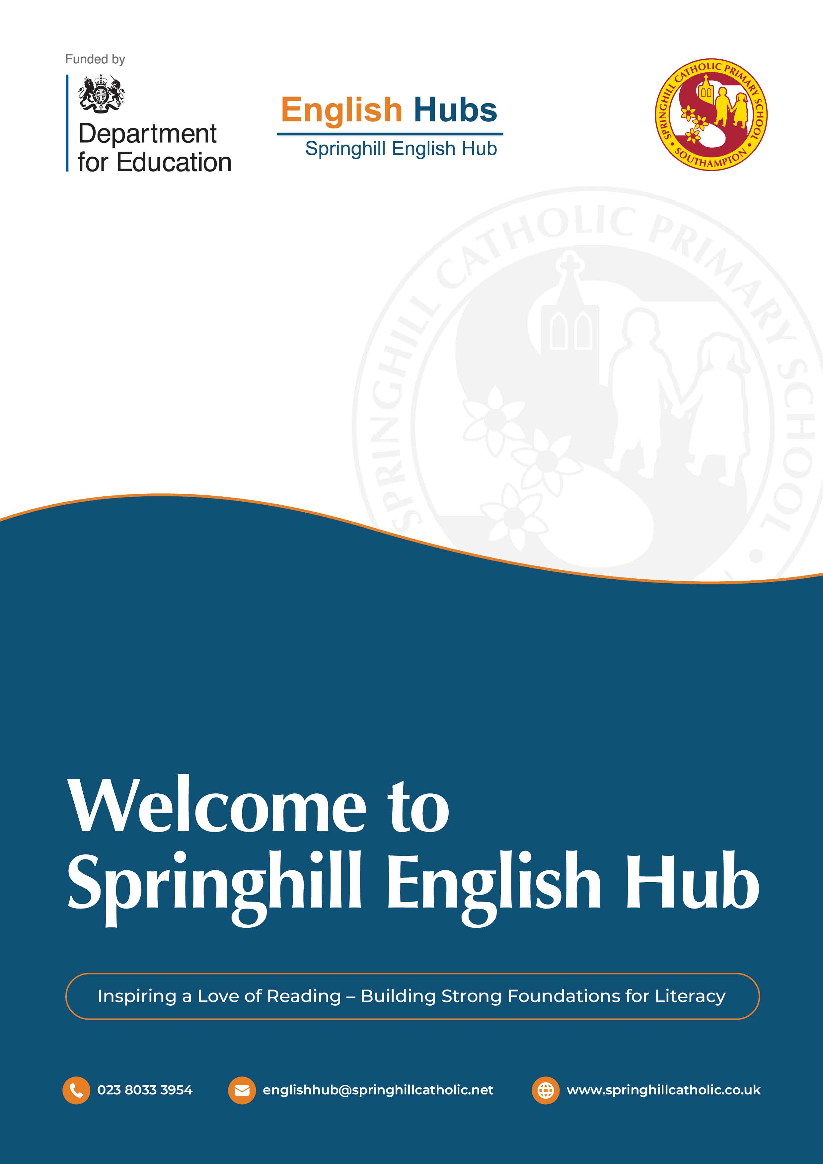
INFORMATION PACK

CONTENTS
About Us 3
About the Role 3
Phase Remits 3
Why Apply? 4
Key Duties 4
Eligibility Criteria 5
Time Commitment and Professional Development 5
How to Apply 6

About Us
Springhill English Hub is one of 34 DfE designated English Hubs selected for excellence in the teaching of reading. To date, the Hub has worked with over 600 primary schools and 10 secondary schools to raise literacy standards in schools and improve the educational outcomes for the most disadvantaged children. Springhill English Hub provides funding, guidance and professional development for colleagues across the South in the following regions:
- Hampshire (including the Isle of Wight)
- Sussex
- Southampton, Portsmouth and Brighton & Hove
The Hub is based at Springhill Catholic Primary School in Southampton, UK. From September 2026, the English Hubs programme will expand its support across Reception, KS1, KS2 and KS3.

About the Role
This is a middle-leadership opportunity which is focused on improving language, literacy and reading outcomes. Specialists may be either:
- employed by their own school and released under secondment (with funded cover) to undertake training and deliver targeted school support, or
- contracted by the English Hub as a freelance literacy specialist.
A Literacy Specialist “day” (LS day) is 1.2 FTE. Schools/contractors will be reimbursed for release time at a rate of £450 per LS day. The amount includes a 0.2 FTE payment of £75 for preparation and follow up activity.
Applicants may apply to work in one or more phases: Reception, KS1, KS2 and/or KS3. At a time of English Hub expansion, this is an opportunity to be at the heart of literacy developments, collaborating to improve outcomes for all the children we serve.

Purpose of the Role
Reception  Early Reading and Phonics | KS1  Early Reading and Phonics | KS2  Phonics and Fluency | KS3  Reading and Reading Catch-up
Supporting high-quality implementation of a school’s chosen SSP, improving early reading and embedding strong teaching practice. | Supporting high-quality implementation of a school’s chosen SSP, improving early reading and embedding strong teaching practice. | Developing effective phonics catch-up and reading fluency provision to secure end-of-KS2 outcomes. | Strengthening reading provision, fluency and intervention to enable full curriculum access and promote reading culture.

Why Apply?
 | Supporting schools to provide the highest quality teaching is a privilege. It is rewarding when you can see the confidence gained by the whole staff, and to be a small part of their improvement journey is amazing. Being a Literacy Specialist enables me to be a more effective educator in my own setting from the insights I’ve gained in this role.”  Louise, Literacy Specialist

This role offers the opportunity to step into leadership while remaining rooted in a school community. You will engage directly with national priorities, DfE training and the latest research, while shaping practice across a regional network.
You will be supported by a collaborative team of literacy specialists and you will experience working with schools in diverse contexts.
The role develops strategic thinking, coaching expertise and change management skills, while making a tangible difference to children’s outcomes.

Key Duties
- Represent the English Hub’s values and promote evidence-informed, high-quality practice.
- Conduct reviews of current practice, diagnose need and co-construct clear action plans.
- Report to the Hub Lead regularly about the delivery of support for all allocated schools.
- Provide intensive in-school support, including modelling, coaching and professional development.
- Support leaders to sequence, monitor and sustain improvement.
- Work strategically with senior leaders to align early reading with whole-school priorities and set aspirational targets for early reading outcomes.
- Support effective implementation and/or application of Systematic Synthetic Phonics (SSP).

Eligibility Criteria –LS for Year R
Qualifications | Essential | - Educated to degree level or equivalent  - Qualified Teaching Status
Qualifications | Desirable | - Relevant postgraduate degree or NPQ  - Full driving licence
Professional Expertise | Essential | - Significant experience teaching systematic synthetic phonics within your chosen phase.  - Strong understanding of pedagogy and the developmental journey to reading.  - Evidence of sustained positive outcomes or demonstrable impact.  - A secure understanding of effective phonics practice.  - Knowledge of DfE’s Reading Framework.  - Excellent communication and organisational skills.
Leadership and Influence |  | - Proven leadership within your school and ability to build trusted partnerships.  - Experience aligning reading with wider school improvement priorities.  - Confidence to provide respectful, evidence-informed challenge.  - Ability to work collaboratively.
Coaching and School Improvement |  | - Skilled in diagnosis through data, observation and professional dialogue.  - Experience in coaching, mentoring and delivering impactful CPD.  - Ability to support effective implementation and sustainable change.
Commitment and Capacity |  | - Currently employed in a school (or able to evidence equivalent impact) with Headteacher support.  - Capacity to commit to required training and development days.  - Commitment to ongoing professional development and system leadership.

Time Commitment and Professional Development

LS under secondment from their own school
With support from their Headteacher, the successful candidate’s allocation of time will be negotiated to ensure that standards and responsibilities within their home school are maintained whilst fulfilling the specialist role. Home schools will be reimbursed for staff release time to enable this commitment.
Ongoing professional development will be provided through the Department for Education (DfE) and the English Hub, with initial training required prior to any deployment. The number of training days will vary depending on the phase the specialist is supporting.
The role and its time allocation will be reviewed biannually.
Given the significant investment in training and support provided through the Department for Education and the English Hub, it is essential that both the supported school and the specialist demonstrate a strong level of commitment to the role. Specialists are expected to fully commit to the responsibilities of the position and to the agreed deployment plan, with the intention of sustaining the role over an extended period of time in order to ensure that schools receiving support are not let down.

LS contracted by the English Hub
The successful candidate’s allocation of time will be subject to negotiation and SSP expertise.
Ongoing professional development will be provided through the Department for Education (DfE) and the English Hub, with initial training required prior to any deployment. The number of training days will vary depending on the phase the specialist is supporting.
The role and its time allocation will be reviewed biannually.
Given the significant investment in training and support provided through the Department for Education and the English Hub, it is essential that both the supported school and the specialist demonstrate a strong level of commitment to the role. Specialists are expected to fully commit to the responsibilities of the position and to the agreed deployment plan, with the intention of sustaining the role over an extended period of time in order to ensure that schools receiving support are not let down.

How to Apply
To ensure we recruit the best possible specialists, we will carry out a rigorous selection process.
This will include:
- Completion of our application form
- A face-to-face interview
- Completion of a task
- Lesson observation
Deadline: 18th May 2026 – 9.00am
Successful applicants will be invited to a face-to-face interview including task completion.
Interview dates to be confirmed.
If you have any further questions or wish to discuss this role in more depth, please do not hesitate to email: englishhub@springhillcatholic.net.

Important Notice
Springhill English Hub is committed to safeguarding and promoting the welfare of children and young people and expects all staff and volunteers to share this commitment. This post is subject to an Enhanced Disclosure check with the Disclosure and Barring Service.

